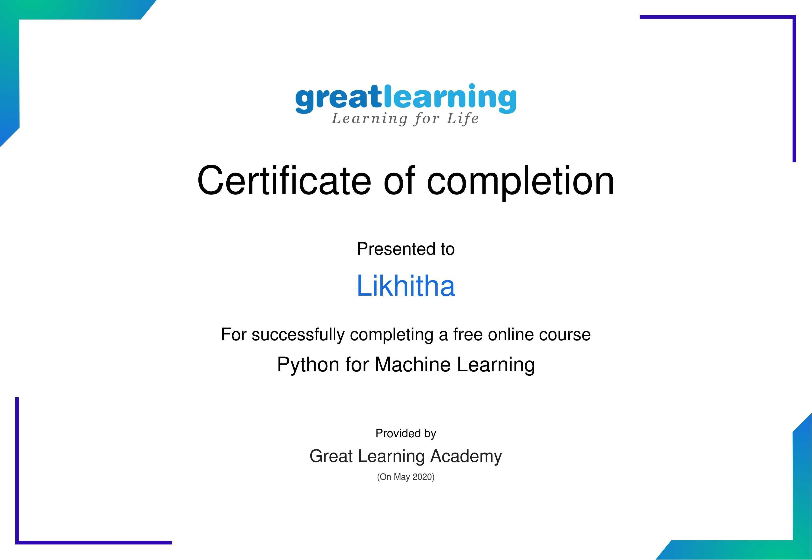

To verify this certificate visit verify.greatlearning.in/DVPLHUPG